NAAC PEER Tem Visit
8, 9 & 10th December, 2016
NAAC PEER Team viisited College on 8, 9 & 10th December, 2016 for the 3rd Cycle of Accreditation. For this visit we have
Chairperson | Dr. K. K. Seethamma,  Former Registrar, Bangalore University, Professor, Department of Economics,  No.227-F, 2nd Floor, Neeladri Apartments, Jayamahal Extension,  Bangalore-560046 | 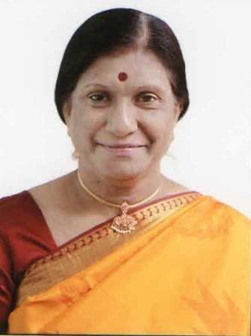
Member Coordinator | Prof. Varinder Kaur Thind,  Former Principal, Khalsa College for Women, Ludhiana  Resi: C-1 (one), Sarabha Nagar,  Ludhiana – 141001, Punjab | 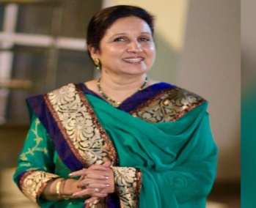
Member | Prof. Mohi-ud-Din Dar (Sangmi),  Department of Commerce,  Director, UGC-HRDC,  University of Kashmir, Hazratbal,  Srinagar -190006, Jammu & Kashmir. | 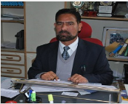
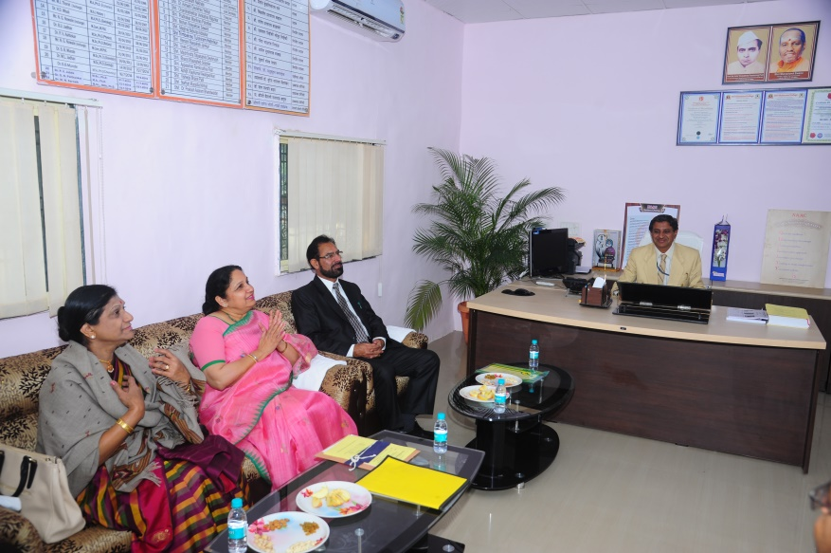
Glimpses of NAAC PEER Team Visit
NAAC PEER Team during interaction with Hon. Principal Dr. M. N. Sarnaik
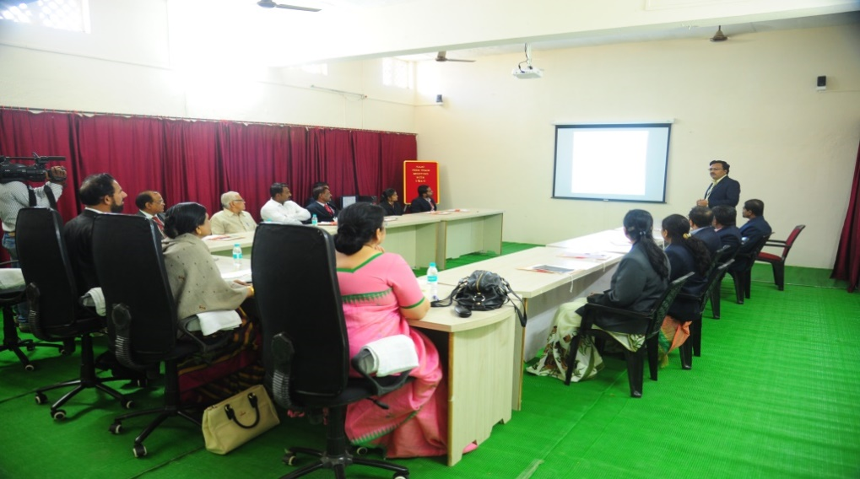

NAAC PEER Team during interaction with IQAC Coordinator Dr. V. B. Jadhav and all IQAC Members

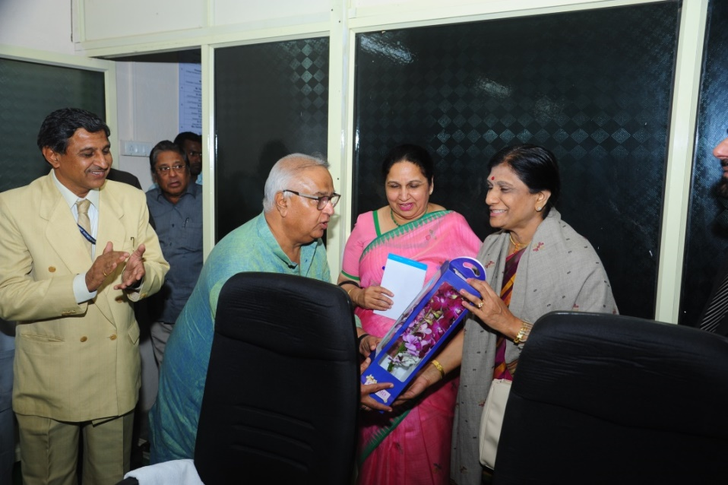
Felicitation of NAAC PEER Team Chairperson with the hands of Hon. Mr. Prakashdada Solanke, President, MSP Mandal, Aurangabad

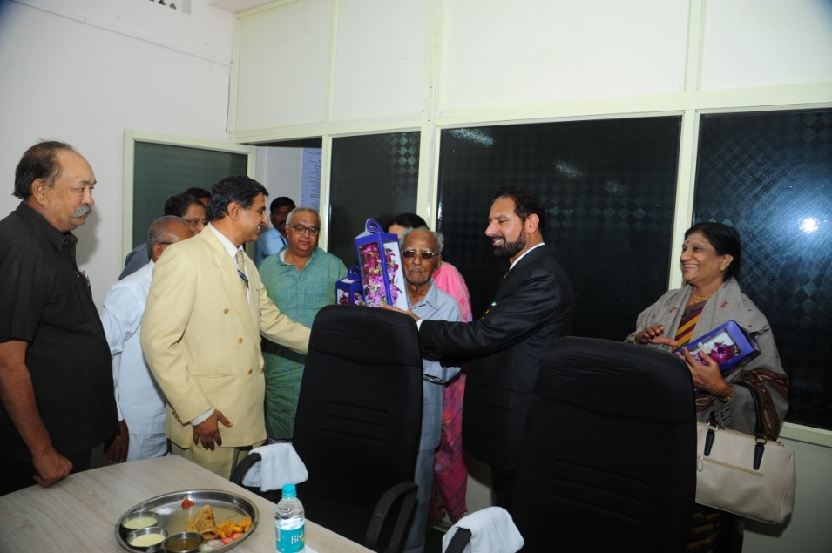
Felicitation of NAAC PEER Team Member with the hands of Hon. Mr. Shaikh Chand Ahmed Chand, Vice- President, MSP Mandal, Aurangabad.

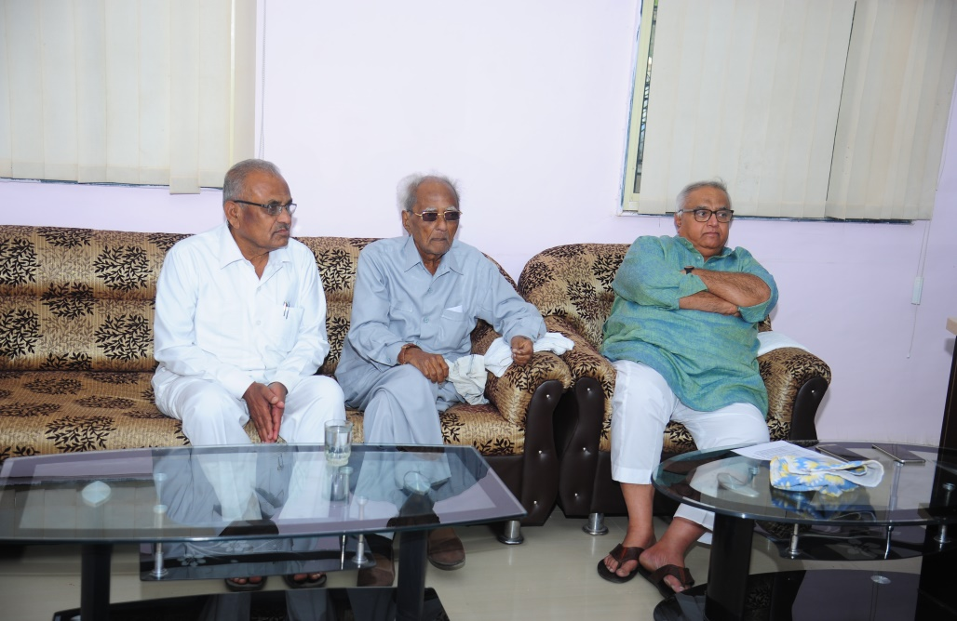

Hon. Mr. Prakshadada Solanke (President MSP Mandal, Aurangabad, Hon. Mr Shaikh Chand Ahmed Chand (Vice-president, MSP Mandal, Aurangabad) and Hon. Adv. Shri Laxmanrao Manal, Member, LMC, Shri Muktanand College, Gangapur.

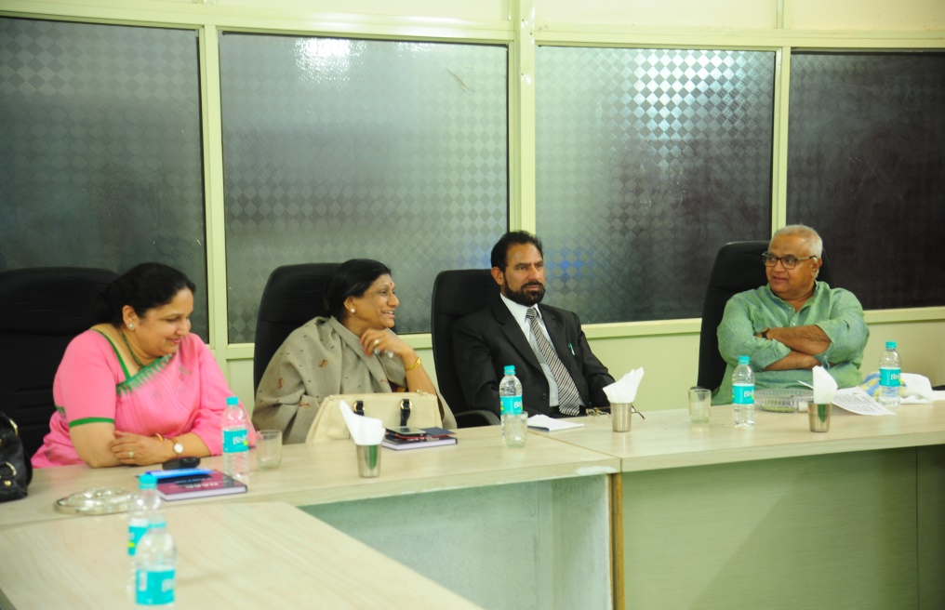
Hon. Mr. Prakshadada Solanke, (President, MSP Mandal, Aurangabad), during Luncheon Interaction with NAAC PEER Team members
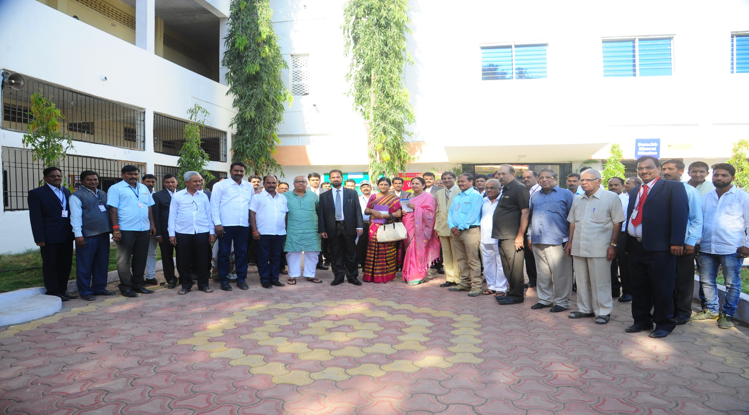
NAAC PEER Team with Members of Central Management & Local Management

